**PROJECT-NAME: PLAYSTATION**

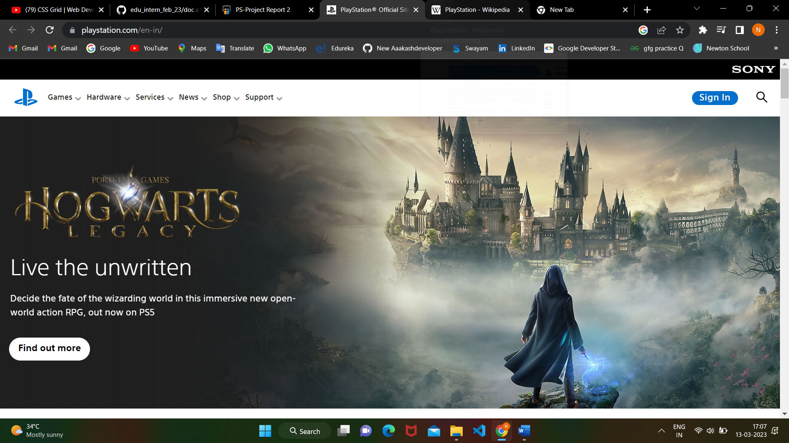

**OVERVIEW: PLAYSTATION** is a [video gaming](https://en.wikipedia.org/wiki/Video_game) [brand](https://en.wikipedia.org/wiki/Brand) that consists of five [home video game consoles](https://en.wikipedia.org/wiki/Home_video_game_console), two [handhelds](https://en.wikipedia.org/wiki/Handheld_game_console), a [media center](https://en.wikipedia.org/wiki/Home_theater_PC), and a [smartphone](https://en.wikipedia.org/wiki/Smartphone), as well as an online service and multiple magazines. The brand is produced by [Sony Interactive Entertainment](https://en.wikipedia.org/wiki/Sony_Interactive_Entertainment).

* **HOME PAGE:**
  + 1. **HEADER**
       1. Logo
       2. Navbar :
          1. Games
          2. Services
          3. Hardware
          4. News
          5. Shop support
       3. Sign in
       4. Search icon
       5. Slider-Images 5(Animation-fade , float in etc)
       6. Heading
       7. Subheading
       8. Button
    2. **First Content Section**
       1. Image Gallery(Aminations)
       2. Moving border box over images with time gap
    3. **Second content section**
       1. Image
       2. Heading
       3. Subheading
       4. Button
    4. **Third content section**
       1. Slider(slider arrow)
          1. New release games available image gallery
          2. 12 images per slide
    5. **Fourth content section**
       1. Playstation store
    6. **Fifth content section**
       1. Slider -playstation blogs
    7. **Sixth content section**
       1. Footer:
          1. Social media icons
          2. Other links
* **SING UP** 
  + 1. **Form(6 section):**
       1. 1 section:
          1. Country
          2. Language

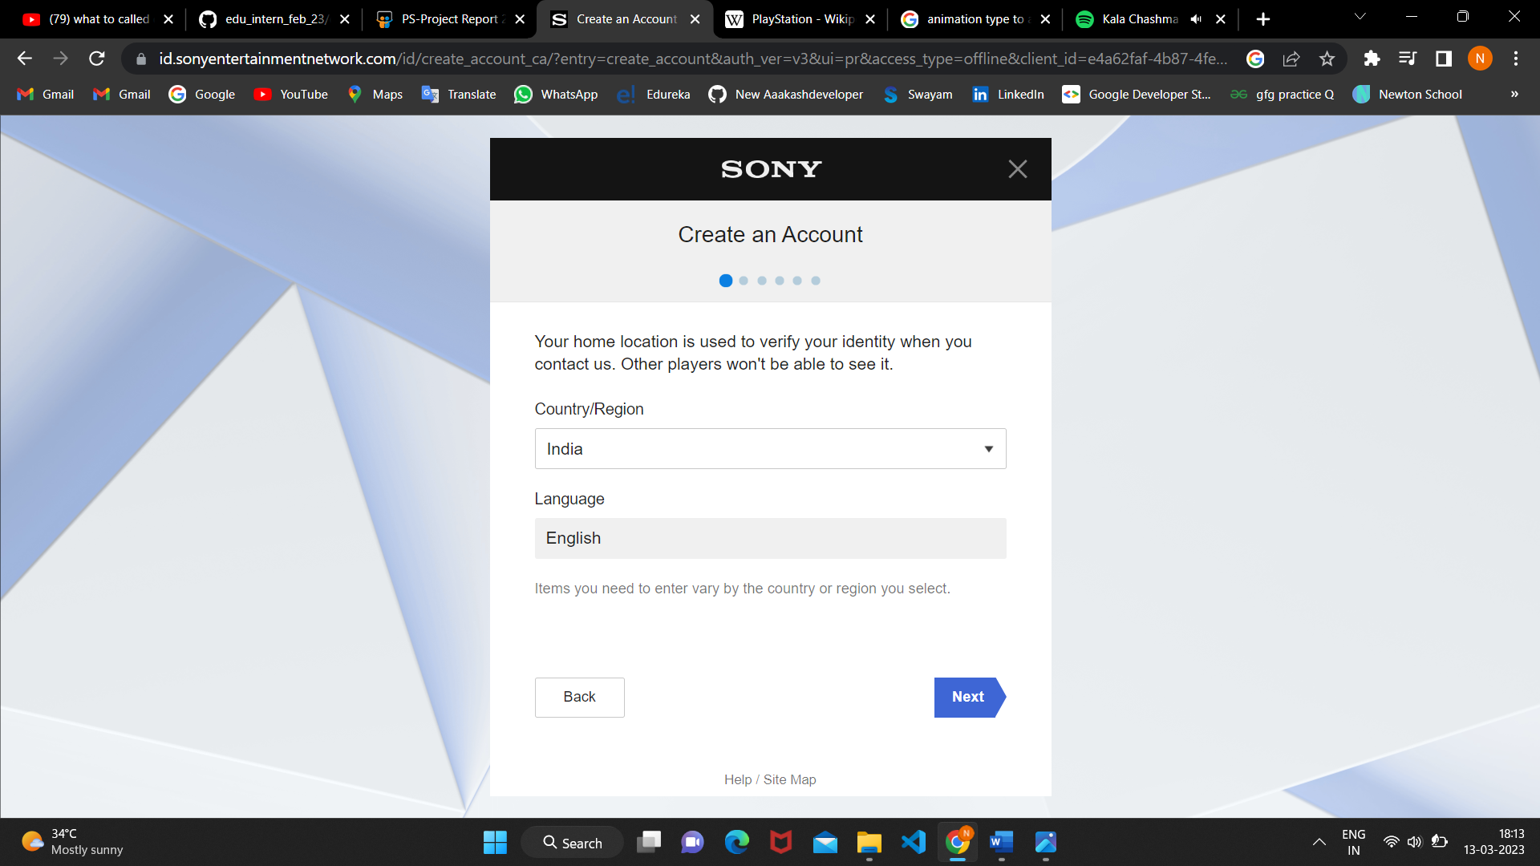

* + - 1. 2 section:
         1. Date of birthday
         2. With some info
      2. 3 section:
         1. E-mail id
         2. Password
         3. Re-enter password
      3. 4 section:
         1. State
         2. City
         3. Passcode
      4. 5 section:
         1. Online game ID
         2. Name-first last
      5. 6 section:
         1. Terms and condition agreemet check

*after sing in 3 more icon added on top left of home page-my profile, wishlist, shopping bucket

* **SHOPPING PAGE-**From home page dropdown

* + 1. **1 Section choosen from slider of games template: Latest, Collection, Deals. PSS, Subscriptions, Browser**
       1. Add to cart
          1. Add payment method
          2. Credit/Debite card
       2. Wishlist
       3. Product description
       4. Diffrent edition
       5. Discount
       6. Footer

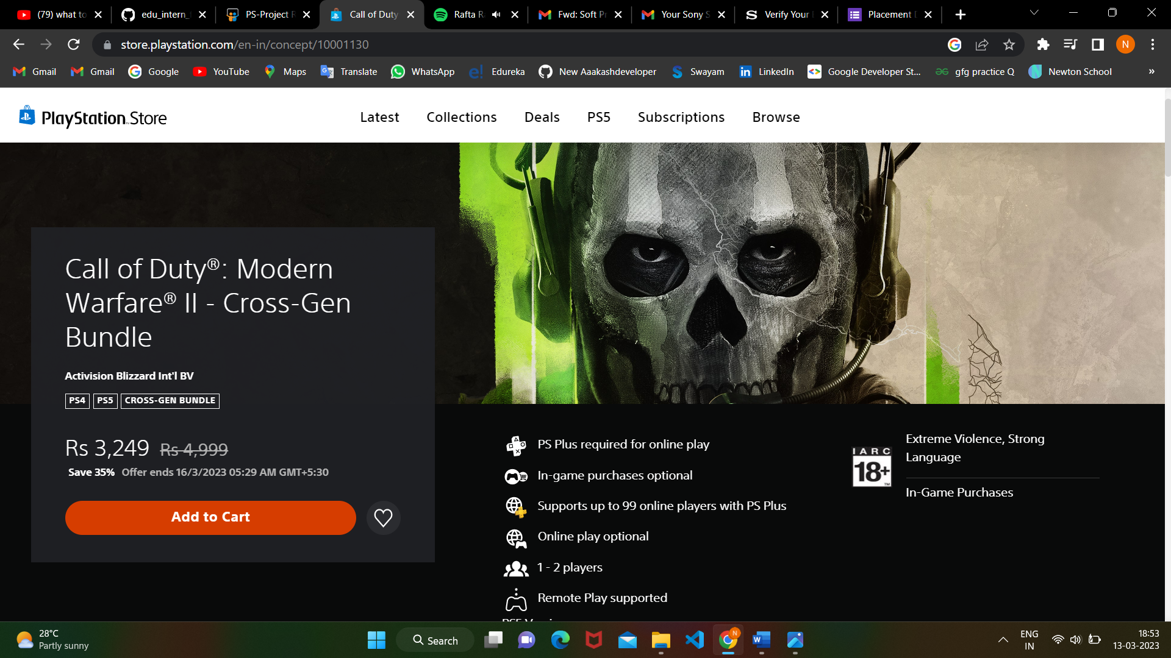

* + 1. **2 section Learn more about playstation**
* **HARDWARE**

1. **About Playstation5, 4 and playstation VR2**



* **SERVICES**

1. **Membership plans**

* **NEWS**

1. **Blogs**

* **SUPPORT**